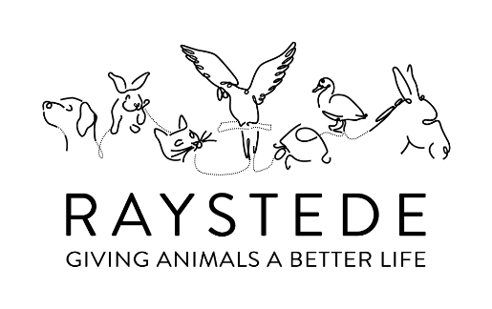
GUESS THE NAME OF THE DOG SWEEPSTAKE INSTRUCTIONS
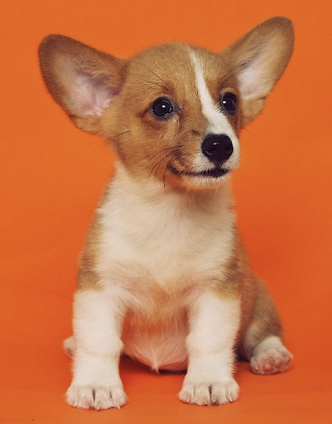
- Decide on a prize to offer to the winner. You could supply an item yourself or approach a local business or shop to ask them to donate a prize.
(If you need a ‘Letter of Authority’ from us to explain that you are fundraising for Raystede, let us know and we’ll get one over to you.)

- Decide on how much you would like to charge each person for entering your Guess The Name Of The Dog Sweepstake. It could be £1, £2, £5 or £10. The amount might depend on the quality of the prize.

- Start asking friends, family and work colleagues to take part in the Guess The Name Of The Dog Sweepstake. They could make the donation to enter directly onto any online fundraising pages, or just give you cash.

- To enter, all they need to do is pick the name of what they think the dog in the photo is called. You then strike off that option so that no-one else can pick it and fill in the table- putting their contact details next to the number of the dog they have gone for.

- When you have received all the entries that you think you will get, let us know and we will give you the name of the dog in the photo and you can notify the winner and give them their prize.

- If you would like to run another Guess The Name Of The Dog Sweepstake, let us know and we can send you another one.

