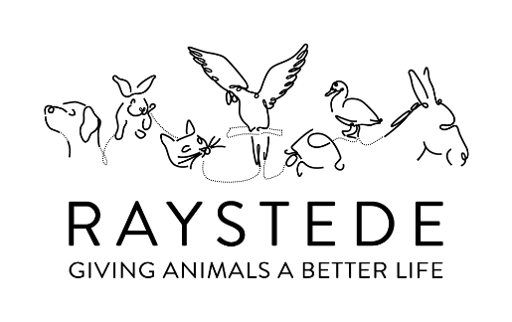
GUESS THE NAME OF THE DOG
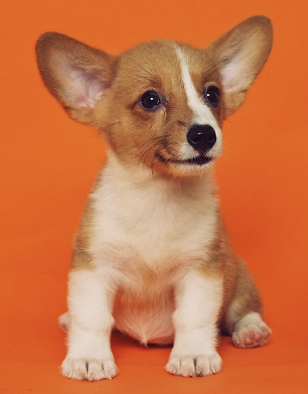
1  Lewis | 2  Star | 3  Milo | 4  Desmond | 5  Sasha | 6  Floyd | 7  Roxy
8  Bertie | 9  Tiger | 10  Manny | 11  Bella | 12  Buddy | 13  Sparky | 14  Ellie
15  Ralph | 16  Albert | 17  Lola | 18  Heidi | 19  Flash | 20  Jasper | 21  Harvey
22  Rusty | 23  Coco | 24  Lloyd | 25  Winston | 26  Tina | 27  Honey | 28  Tinkerbell
29  Willow | 30  Lucy | 31  Twiggy | 32  Lucky | 33  Misty | 34  Polly | 35  Jason
36  Tango | 37  Bear | 38  Stitch | 39  Hermione | 40  Ringo | 41  Popsicle | 42  Katie
43  Sherlock | 44  Layla | 45  Maddison | 46  Leonardo | 47  April | 48  Jasmine | 49  Billy

